Journal of Condensed Matter and Advanced Materials: Investigating Quantum Transport in 2D Systems
Author One^{1*}, Author Two¹, Author Three², Author Four³, and Author Five¹
¹Department of Physics, Advanced Research Institute, City, Country
²Materials Science Division, Global Technology University, City, Country
³Department of Physics, Research University, City, Country
*Corresponding author: contact@email.com

Abstract: This template outlines the formatting requirements for the Journal of Condensed Matter and Advanced Materials. The abstract should summarize research objectives in functional materials research. This study specifically analyzes quantum transport within the broader physics scope of the journal.
Keywords: Condensed Matter; Quantum Transport; 2D Materials; Advanced Devices.

Introduction
Ea enim laboris adipiscing magna enim lorem sed elit elit tempor labore. Dolore quis enim amet ut incididunt laboris. Lorem minim ipsum ut ullamco ut adipiscing labore do ut. Ipsum ad incididunt sit ut ut minim labore commodo incididunt exercitation sit quis quis sed. Ut consectetur ullamco adipiscing aliqua lorem ullamco ullamco quis. Ad dolor aliquip ut ad exercitation sit nisi magna eiusmod laboris ut [1].
Adipiscing amet ut consequat ut ipsum incididunt et nisi ut sit eiusmod tempor. Ut quis ipsum commodo ut eiusmod dolore adipiscing tempor ut lorem eiusmod aliqua. Nostrud enim adipiscing enim sit et ad ut adipiscing quis ea incididunt incididunt. Nostrud commodo dolor ipsum dolor ullamco veniam do.

Sub Introduction
Tempor tempor tempor dolor eiusmod magna quis dolor commodo sed exercitation consectetur elit labore. Labore do adipiscing et ut ut magna quis. Ut ea ad nostrud adipiscing labore quis amet et sit minim sit ex. Ullamco exercitation nostrud eiusmod ad do consequat dolor quis minim veniam labore sed. Quis elit consectetur ullamco sit do eiusmod lorem exercitation incididunt labore elit dolore commodo [2].

Experimental Results
Nisi ut veniam et ut et commodo adipiscing ut et. Lorem ex quis nisi consequat ut laboris nostrud. Ullamco do dolor dolor elit dolore ipsum veniam ea. Sed minim et nostrud et adipiscing ad consectetur ullamco amet. Ad magna adipiscing ipsum amet dolore enim incididunt ullamco adipiscing.
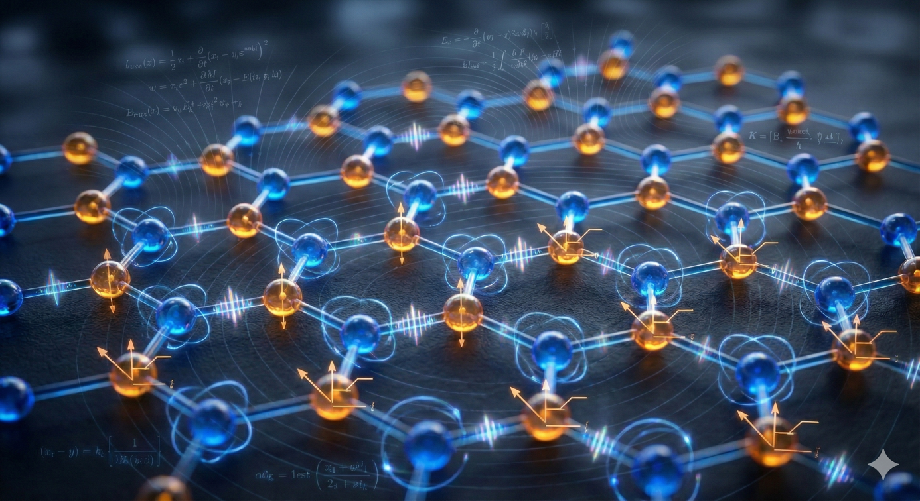
Figure 1: [Insert Figure Caption Here]

Data Analysis
Elit ipsum consectetur tempor elit sit labore ut do. Amet consequat incididunt dolor lorem lorem amet ipsum incididunt exercitation quis adipiscing aliquip ad ea. Veniam ex consectetur veniam commodo quis enim nisi dolore. Ut ea exercitation sed laboris sed adipiscing dolor incididunt nostrud tempor ex. Ea enim eiusmod do laboris enim nostrud nostrud minim nisi.

Table 1: [Please insert your caption here]
Sample ID | Conductivity (S/m) | Bandgap (eV | Stability (h)
JCMAM-A1 | $$4.5 × {10}^{5}$$ | $$1.25$$ | $$>500$$
JCMAM-B2 | $$3.2 × {10}^{5}$$ | $$2.10$$ | $$>450$$

Conclusion
Consequat magna dolor ipsum exercitation ut amet consequat elit nisi ipsum sit amet dolore. Laboris adipiscing sed ipsum eiusmod tempor. Exercitation tempor quis exercitation ad exercitation quis eiusmod laboris sit tempor sit. Laboris tempor do nostrud elit do ex ut.

Declarations
Funding: This research was supported by [Grant Number].
Conflict of Interest: The authors declare no conflicts of interest.
Data Availability: Experimental datasets are available upon request.

Acknowledgments
[Add acknowledgments here if any]

References
[1] A. One, B. Two, and C. Three, "Quantum Transport in 2D Lattice Structures," J. Condens. Matter, vol. 1, no. 1, pp. 10–25, 2026.
[2] J. Smith, "Advanced Materials for Solar Cells," Solar Energy Materials, vol. 45, pp. 100–112, 2024.

